1.Resistive load NMOS inverter circuit

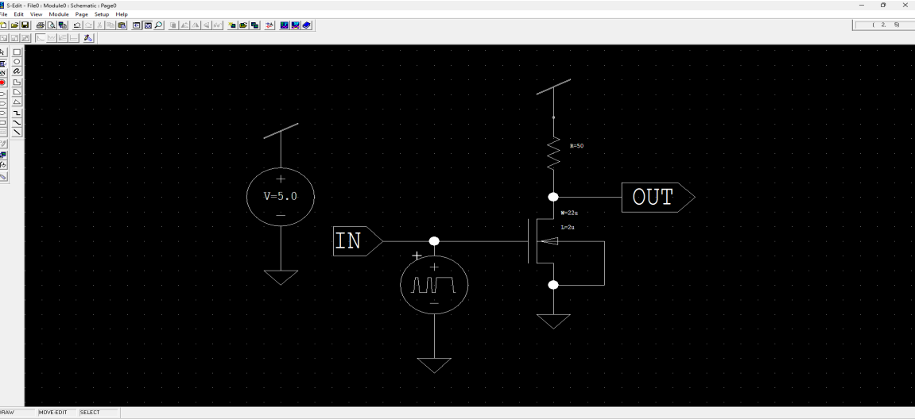
o/p:-
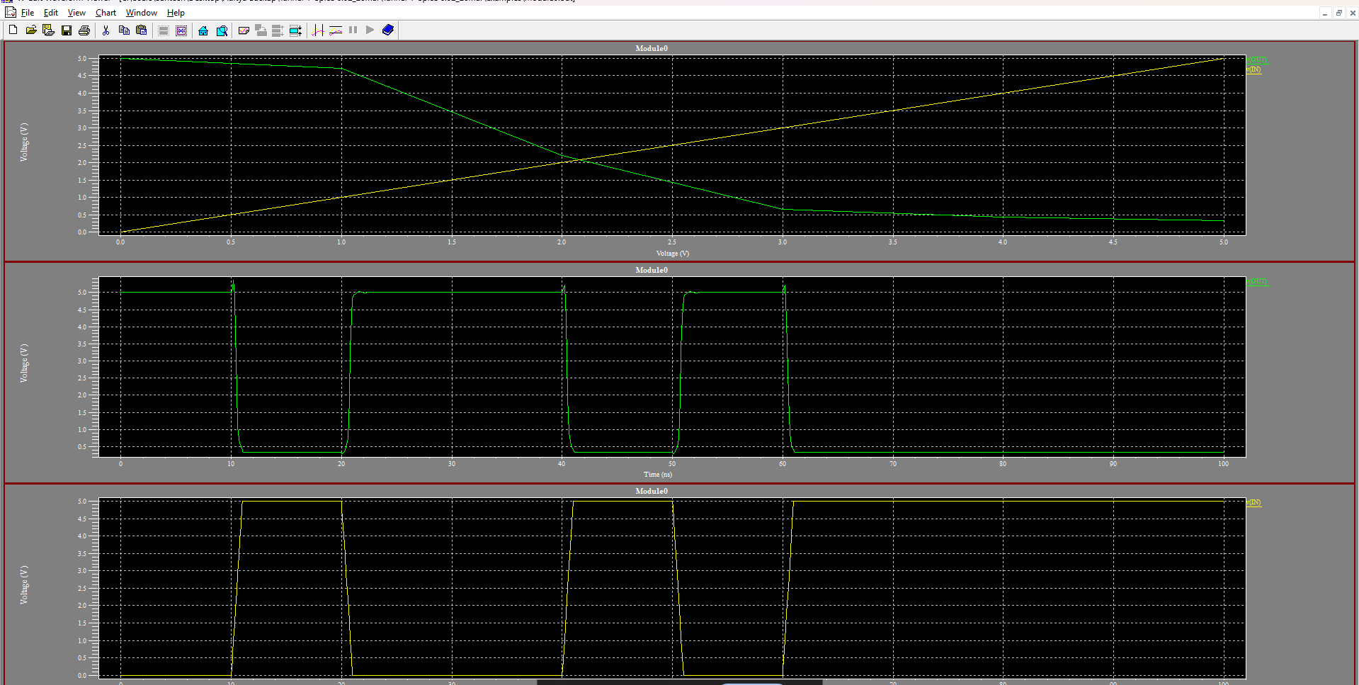

.dc v3 0 5v 1v
.print V(IN) V(OUT)
.tran lns 100ns
.print V(IN) V(OUT)
.end

2,saturated nmos

Here is the extracted text from the image:
M1 Vdd Vdd out Gnd NMOS L=2u W=22u AD=66p PD=24u AS=66p PS=24u
M2 out in Gnd Gnd NMOS L=2u W=22u AD=66p PD=24u AS=66p PS=24u
v3 in Gnd bit({0100101111} on=5.0 off=0.0 )
v4 Vdd Gnd 5.0
.dc V3 0V 5V 1V
.print V(in) V(out)
.tran 1ns 100ns
.print V(in) V(out)
.end

3.linear enhancement nmos
Here is the extracted text from the image:
M1 Vdd N3 OUT Gnd NMOS L=2u W=22u AD=66p PD=24u AS=66p PS=24u
M2 OUT IN Gnd Gnd NMOS L=2u W=22u AD=66p PD=24u AS=66p PS=24u
v3 IN Gnd bit({0100101111} | on=5.0 off=0.0 )
v4 N3 Gnd 3.0
v5 Vdd Gnd 5.0
.dc V4 0V 5V 1V
.print V(IN) V(OUT)
.tran 1ns 100ns
.print V(IN) V(OUT)
.end

Exp 8 sram

.tran 1ns 100ns
.print WL BL BLB Q QB
.end

Exp 6- (1)2:1 mux
V7 S Gnd bit({10001111}) on=5.0 off=0.0
V8 B Gnd bit({01010101}) on=5.0 off=0.0
V9 A Gnd bit({11110100}) on=5.0 off=0.0
* End of main circuit: Module0

.tran 1ns 100ns
.print V(A) V(B) V(S) V(Y)

(2)4:1 mux
v19 S0 Gnd bit({0101010101} on=5.0 off=0.0) v20 P1 Gnd bit({0010110101} on=5.0 off=0.0) v21 P0 Gnd bit({0100101110} on=5.0 off=0.0) v22 P2 Gnd bit({1101100010} on=5.0 off=0.0) v23 P3 Gnd bit({1100110011} on=5.0 off=0.0) v24 S1 Gnd bit({0100101111} on=5.0 off=0.0) v25 S3 Gnd bit({0100101111} on=5.0 off=0.0) v26 Vdd Gnd 5.0 * End of main circuit: Module0 .tran 1ns 100ns .print V(P0) V(P1) V(S0) V(P2) V(P3) V(S1) V(S3) V(F)

Exp 4- 2ip cmos nand
v5 A Gnd bit({0100101111} on=5.0 off=0.0)
v6 B Gnd bit({0100101111} on=5.0 off=0.0)
v7 Vdd Gnd 5.0
.tran 1ns 100ns
.print V(A) V(B) V(OUT)
.end

2ipCmos nor
v5 B Gnd bit({00110011} on=5.0 off=0.0)
v6 A Gnd bit({01010101} on=5.0 off=0.0)
v7 Vdd Gnd 5.0
.tran 1ns 100ns
.print V(A) V(B) V(OUT)
.end

Exp3
Cmos inverter with diff kr values

1.For Pmos when l=10u, w=55u
For Nmos when l=5u, w=33u

M1 out in Gnd Gnd NMOS L=5u W=33u AD=66p PD=24u AS=66p PS=24u
M2 out in Vdd Vdd PMOS L=10u W=55u AD=66p PD=24u AS=66p PS=24u
v3 in Gnd bit({0100101111} on=5.0 off=0.0)
v4 Vdd Gnd 5.0
.dc v3 0 5v 1v
.tran 1ns 100ns
.print V(in) V(out)

2.For Pmos when l=45u w=90u
For Nmos when l=35u w 70u

M1 out in Gnd Gnd NMOS L=35u W=70u AD=66p PD=24u AS=66p PS=24u
M2 out in Vdd Vdd PMOS L=45u W=90u AD=66p PD=24u AS=66p PS=24u
v3 in Gnd bit({0100101111} on=5.0 off=0.0)
v4 Vdd Gnd 5.0
.dc v3 0 5v 1v
.tran 1ns 100ns
.print V(in) V(out)

